Excel
The objective is to clean and standardize the data in the 'Spotify2' sheet. This includes: identifying and removing duplicate records, detecting and handling missing values appropriately, and using VLOOKUP to cross-reference or fill in data where needed. The final output should be presented in a clean, standard tabular format — with consistent headers, proper data types, and no inconsistencies ready for further analysis
- Find the sum of Total stream in million
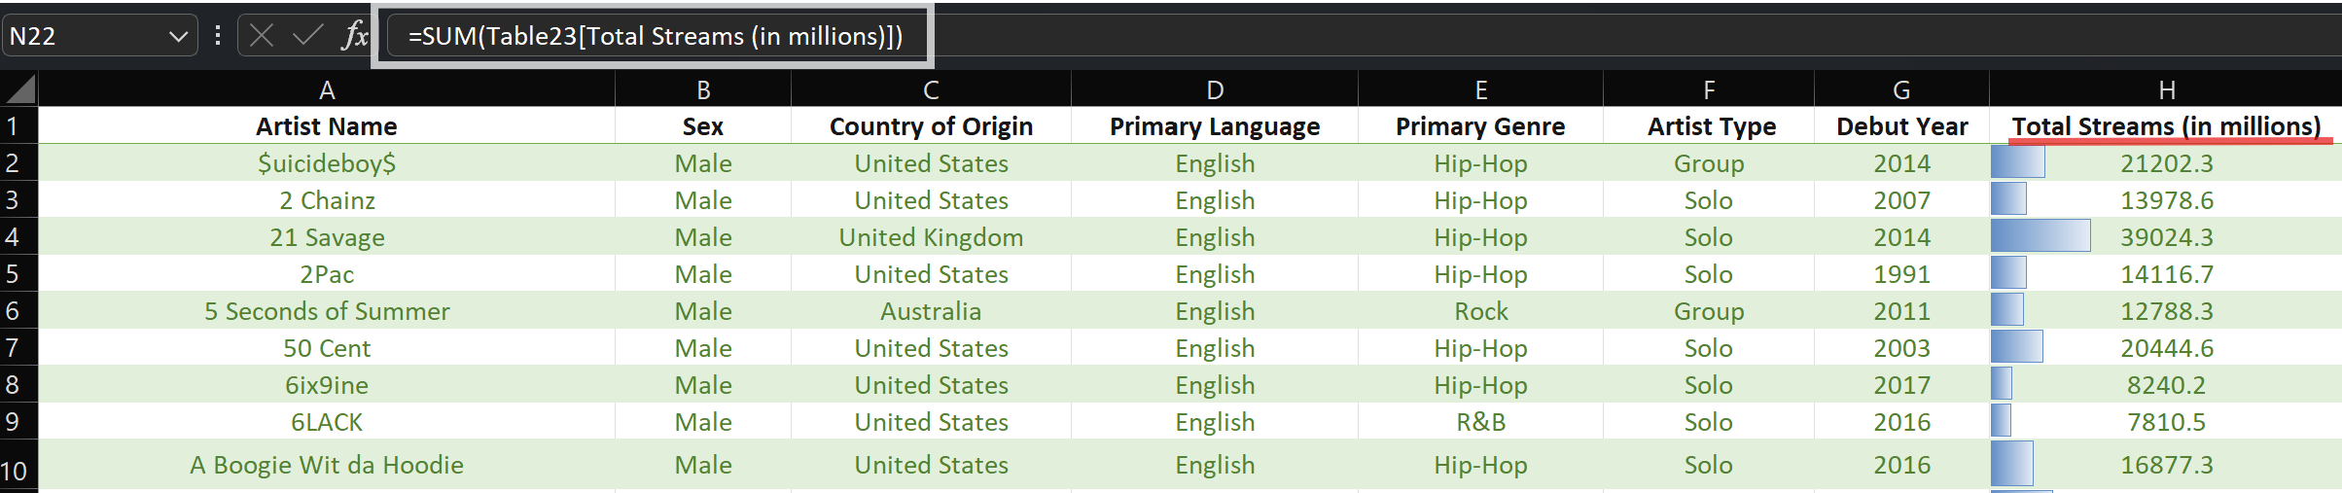
- Average of Total stream in million
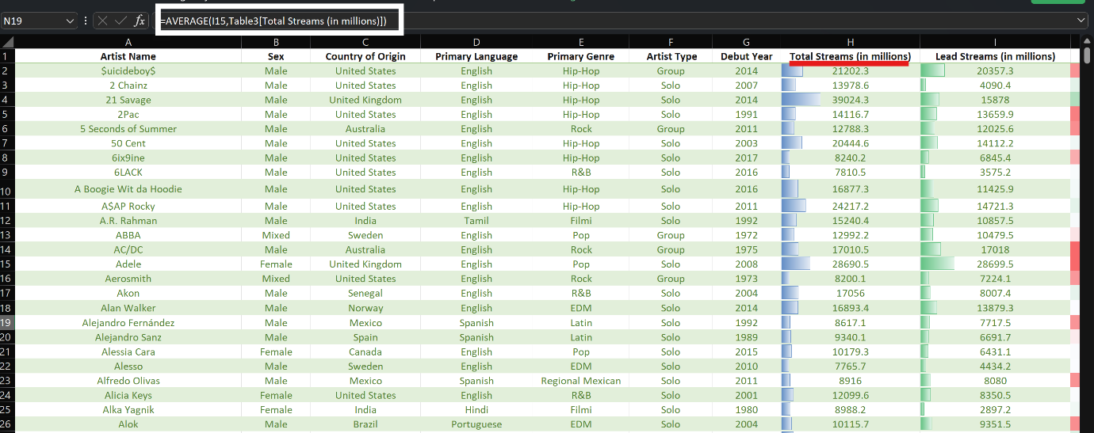
- Min and Max value of sheet.
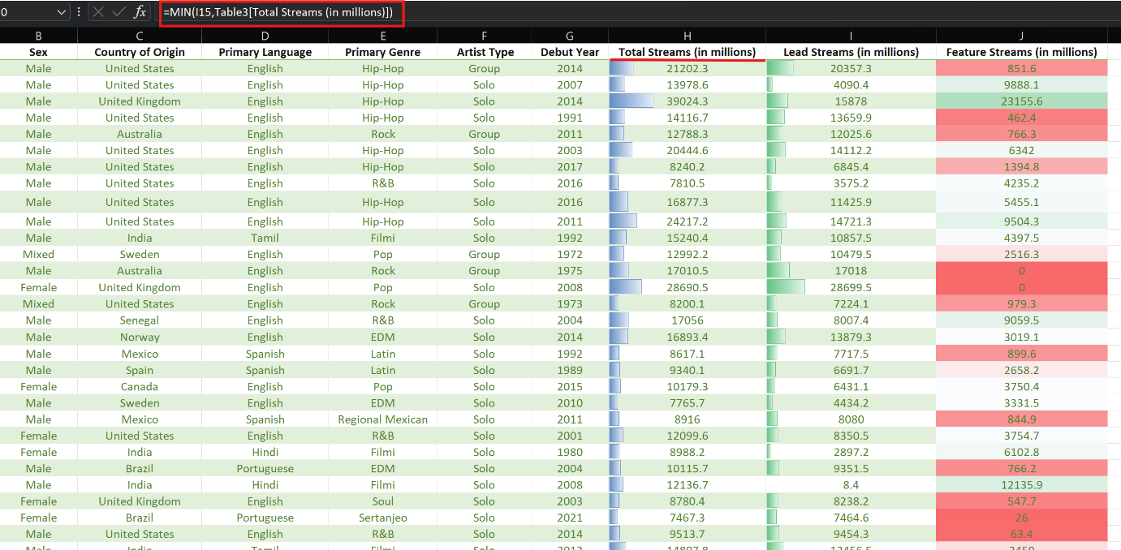

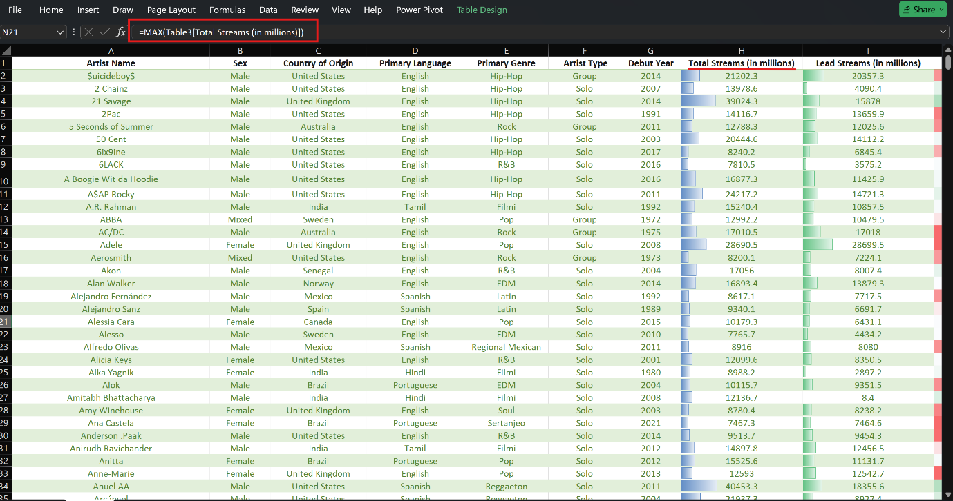

Count of total Artist performed
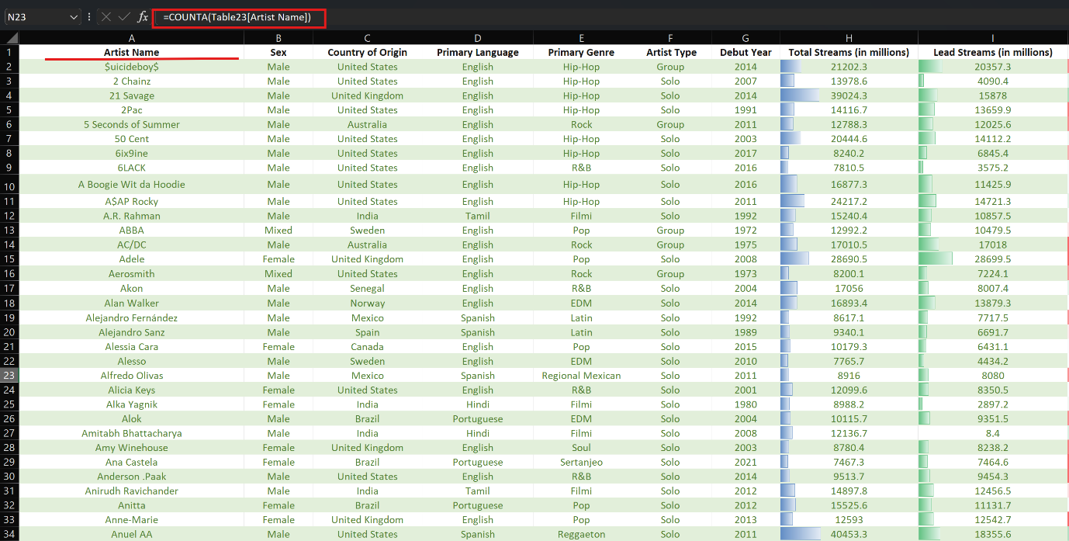

Pivot Table
Create a pivot table with cleaned datasheet spotify2
- Created a country-wise pivot table summarizing total streams alongside artist names, enabling clear identification of top-performing artists and streaming trends by region.
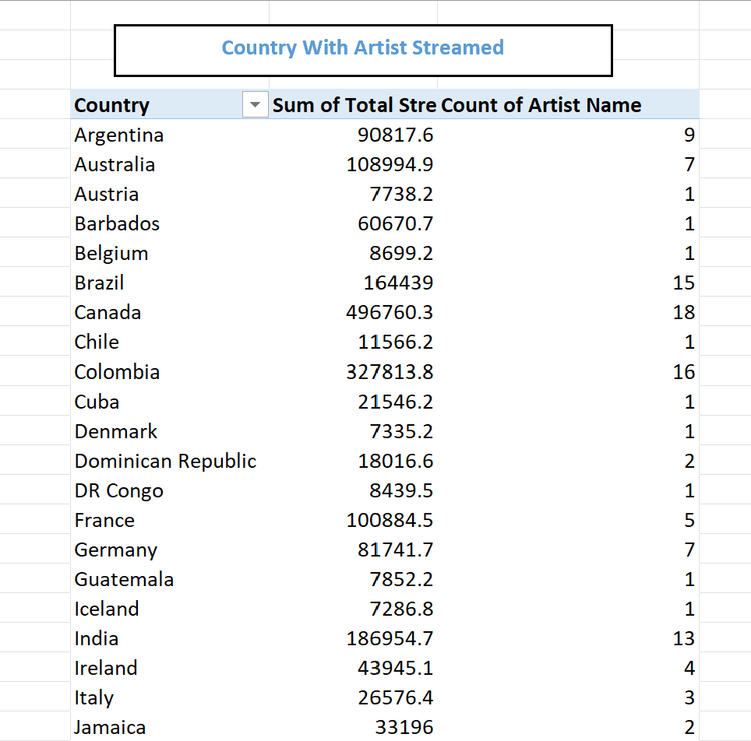

- Created a pivot table analysing total streams by genre, enabling clear comparison of streaming performance across different music genre.

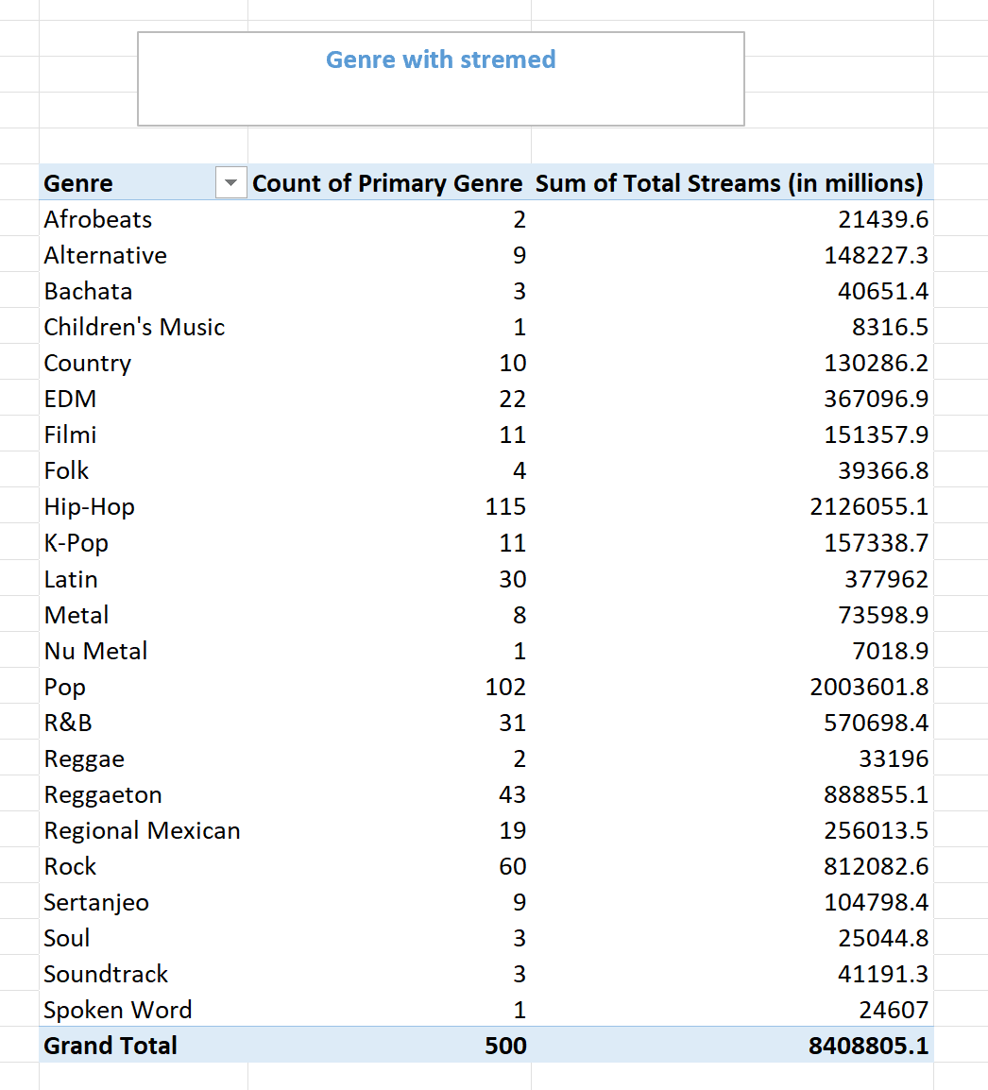

- Created a pivot table analysing total streams by debut decade, revealing streaming trends across different artist era.
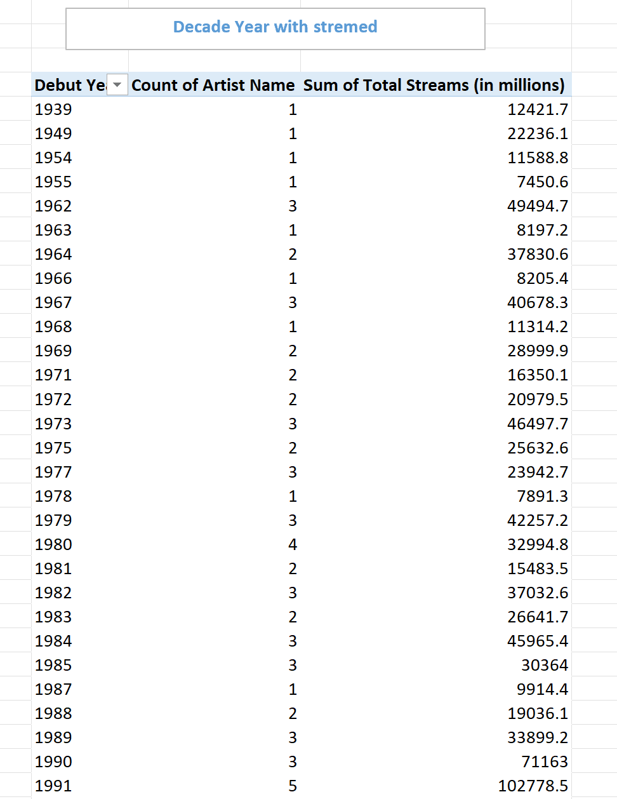
- Created a pivot table cross-analysing artist type with genre, highlighting genre distribution patterns among solo artists versus groups.
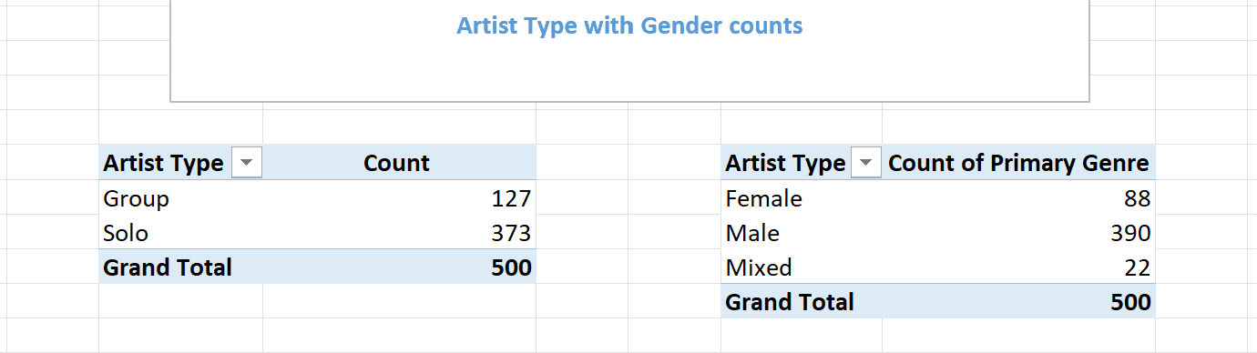

Power BI
Created and formatted various visualization charts in Power BI, applying consistent styling, appropriate chart types, and clear labelling to effectively communicate data insights.
Total stream by Music genre
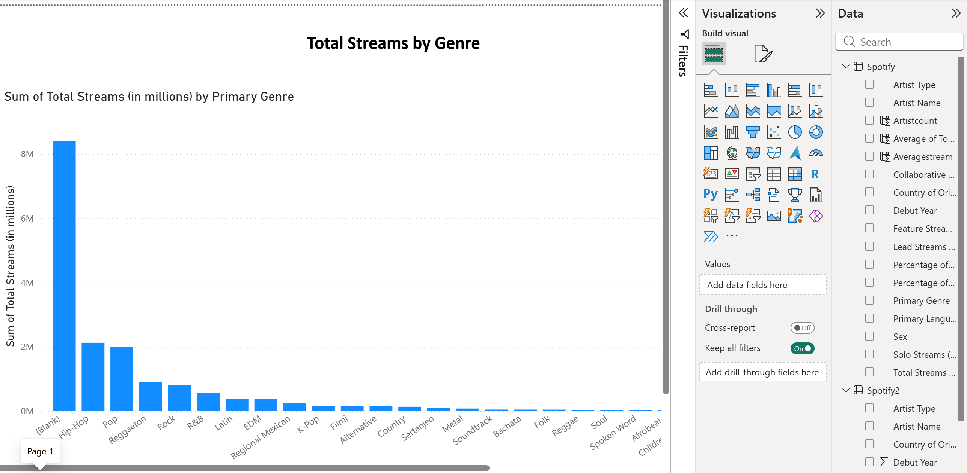

Artist sings in Gender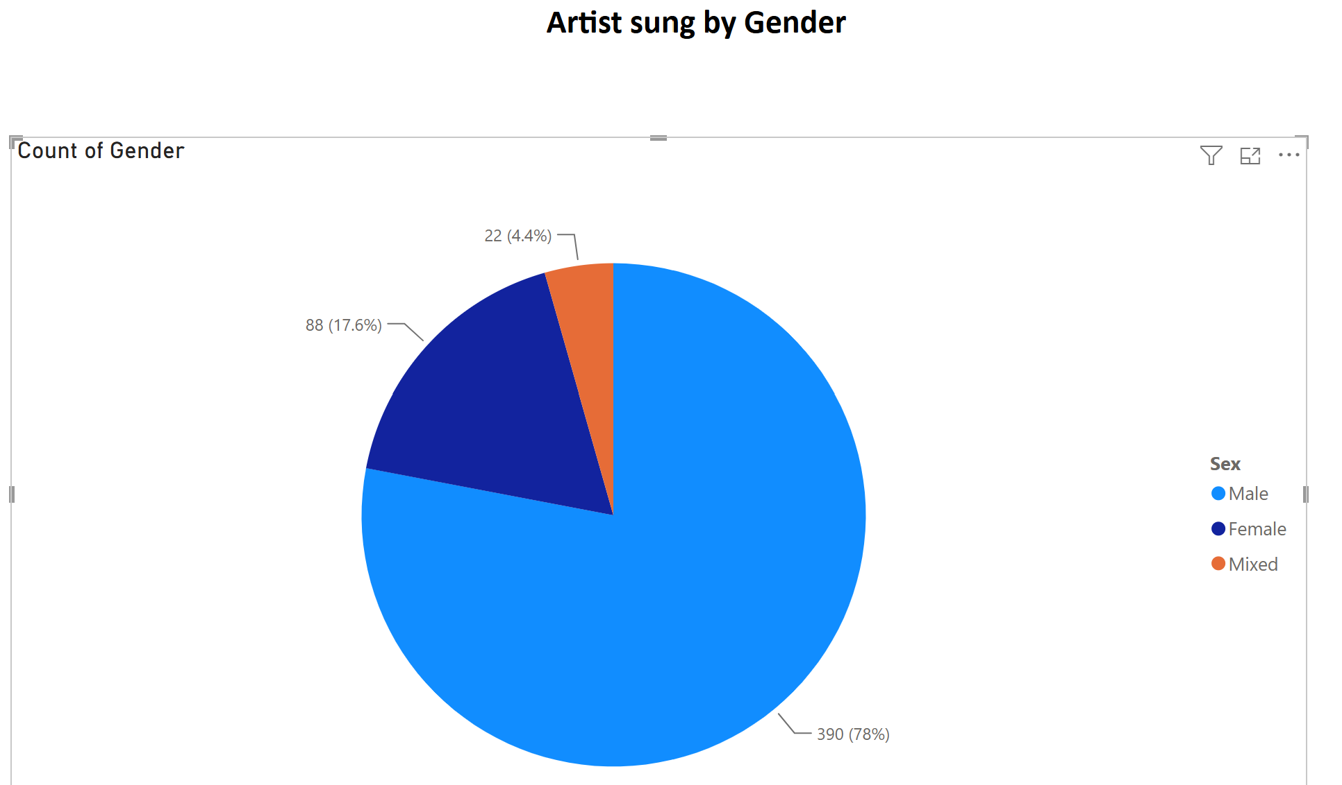

Featuring of Debut year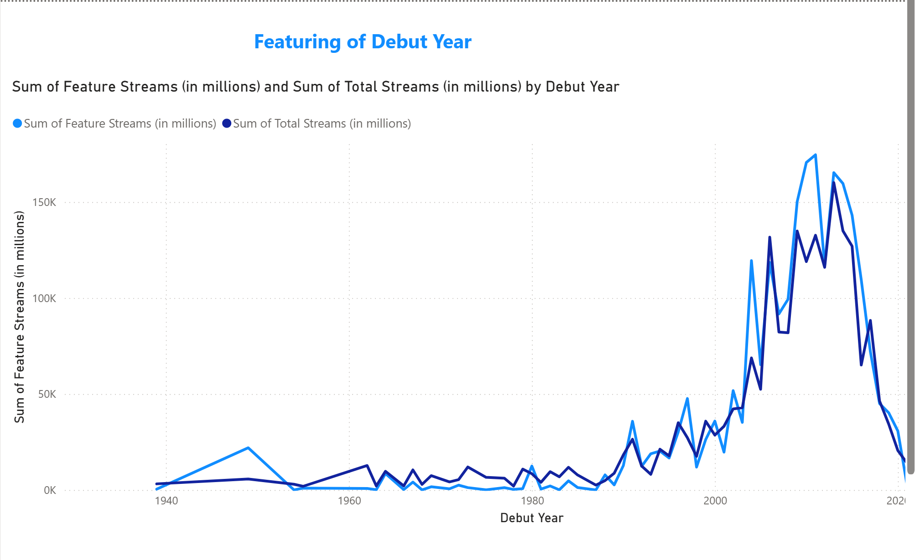

Artist with countries count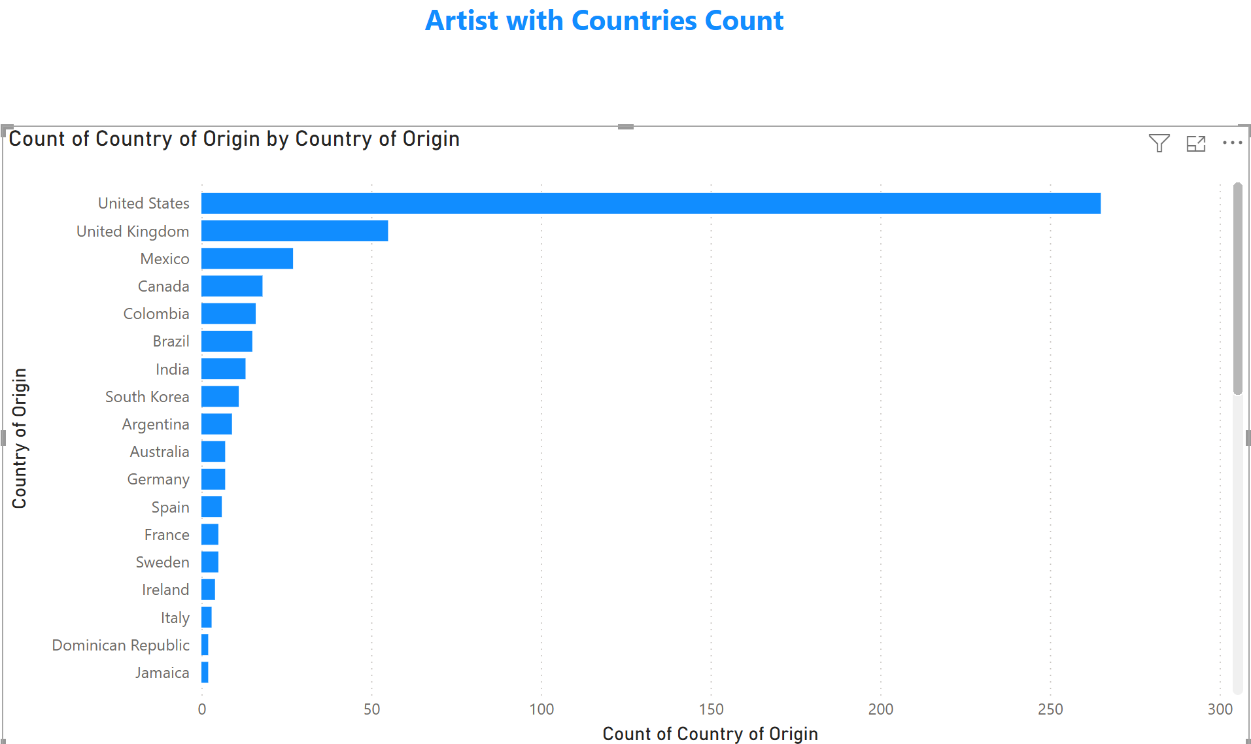

Total stream with countries origin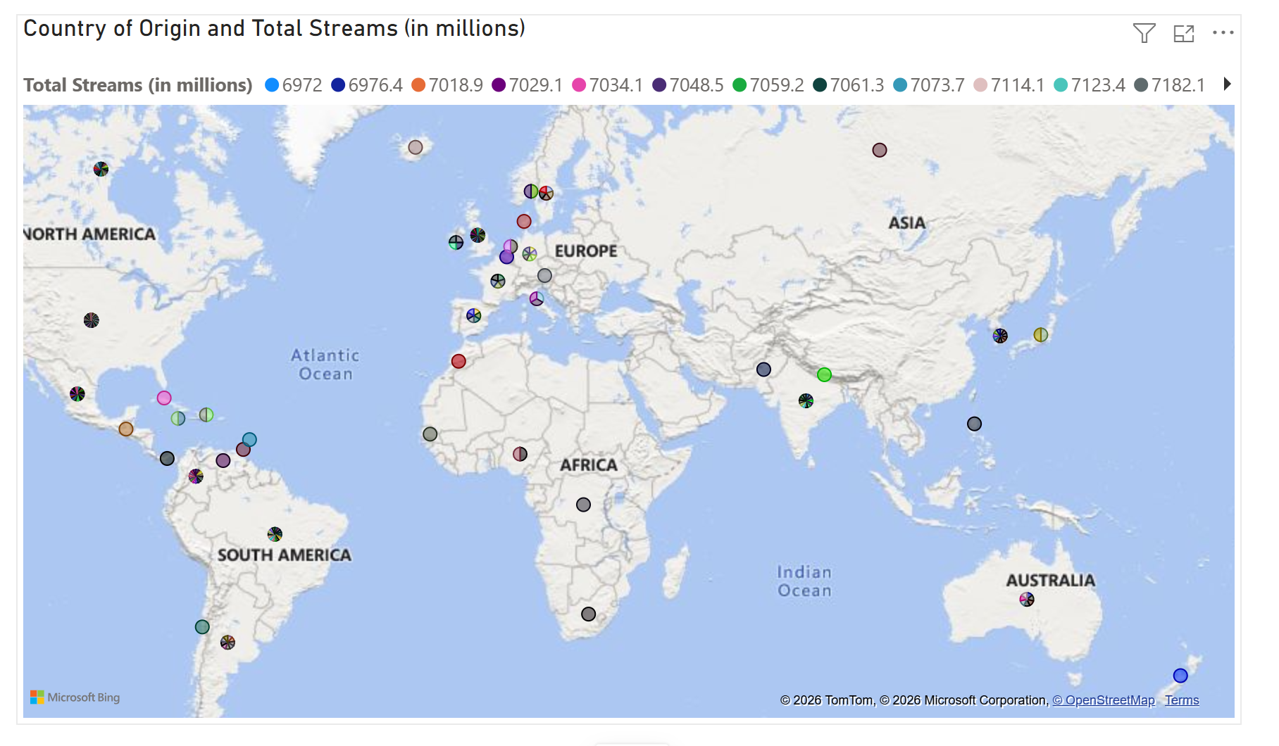

Summary
In this case, there are the same 500 records with 10 core columns (no derived Solo/Collaborative split). In order to proceed with the cleaning process, this copy was used as an intermediate working copy; it contains a few empty trailing columns with no data in them. Here is a version of the raw data that has been further cleaned (10 core columns, 500 records, duplications and blank rows have been removed). It was this sheet that was referenced in the data-cleaning task (VLOOKUP-based standardization, duplicate removal, missing-value handling) prior to the final Spotify sheet being created. And power Bi file Create a bar chart in power bi cluster for total stream in genre, artist sung in gender pie chart, line chart for featuring in debut year, bar chart for artist with countries count, and a map visualisation of countries with total streams.

